As a | Registered online user
I want | To view the following 2 categories in ‘My account Coupons’ section (in desktop & mobile):  - Use Anywhere  - Online-Only Coupons
So that | I can clearly distinguish between coupons that can be used anywhere versus coupons which are online only
Acceptance Criteria | - System shall add the following 2 categories in ‘My account Coupons’ section (in desktop & mobile):  - Use Anywhere  - Online-Only Coupons  - ‘Use Anywhere’ category shall display the following:  - Coupon Image  - Coupon Title  - Coupon Expiry Date  - Coupon Description  - Option to:  - Apply Coupon: On selecting this option, system shall……………<Write the behavior of what happens)  - Redeem Coupon: On selecting this option ……………<Write the behavior of what happens)  - Print Coupon: On selecting this option ……………<Write the behavior of what happens)  - ‘Online-Only Coupon’ category shall display the following:  - Coupon Image  - Coupon Title  - Coupon Expiry Date  - Coupon Description  - Option to:  - Apply Coupon: On selecting this option, system shall……………<Write the behavior of what happens)
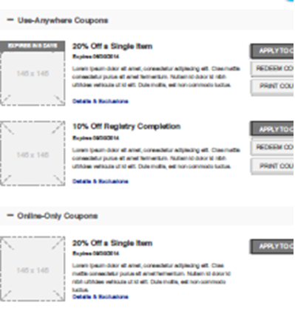

Section | Field Name | Field Type | Content | Min Char | Max Char | Notes
Use Anywhere Coupons | <Coupon Image> | Image | n/a | n/a | n/a | Image Size: ??
 | <Coupon Name> | Read Only | Alpha Numeric | ?? | ??
 | <Coupon Name> | Read Only | Alpha Numeric | ?? | ??
 | Expires <mm/dd/yyyy> | Read Only | Alpha Numeric | ?? | ??
 | <Coupon Description> | Read Only | Alpha Numeric | ?? | ??
 | Apply To Card | Command Button
 | Redeem Coupon | Command Button
 | Print Coupon | Command Button
Online-Only Coupons | <Coupon Image> | Image | n/a | n/a | n/a | Image Size: ??
 | <Coupon Name> | Read Only | Alpha Numeric | ?? | ??
 | <Coupon Name> | Read Only | Alpha Numeric | ?? | ??
 | Expires <mm/dd/yyyy> | Read Only | Alpha Numeric | ?? | ??
 | <Coupon Description> | Read Only | Alpha Numeric | ?? | ??
 | Redeem Coupon | Command Button

